**TASK-2**

Use Case - There is a team who wants to migrate organization details from postgres DB to Salesforce custom object created in Task 1.

Task:

* Inside Mulesoft
* orgs-legacy-sapi - **4 Hours**
* Create a docker instance for postgres
* tableName - businesses.
* Create an API Specification for Orgs-Legacy-SAPI
* Create an endpoint called health check and endpoint to retrieve the data from Postgres. Implement the SAPI.
* Write Munits
* deploy the app to Hybrid
* orgs-migrate-papi
* Create an STM (Source Target Mapping) document explaining which fields in postgres map to which fields in salesforce.
* Create an API specification for Orgs-Migration-PAPI
* Create an endpoint called health check and endpoint to start migrate
* Implementation:
* Health Check:
* trigger orgs-legacy-sapi health check
* trigger salesforce-sapi health check
* If both success, return success
* Otherwise, failure
* Migrate
* Fetch 100 records from Postgres
* Transform the data to match salesforce sapi endpoint
* Trigger the salesforce-sapi endpoint to create records in salesforce
* Write Munits
* deploy the app to Hybrid

Docker Image downloading:

We need to download the postgres image from docker hub using pull command.  
If you have an instance already running, you can just start the container which will start the postgres database directly.

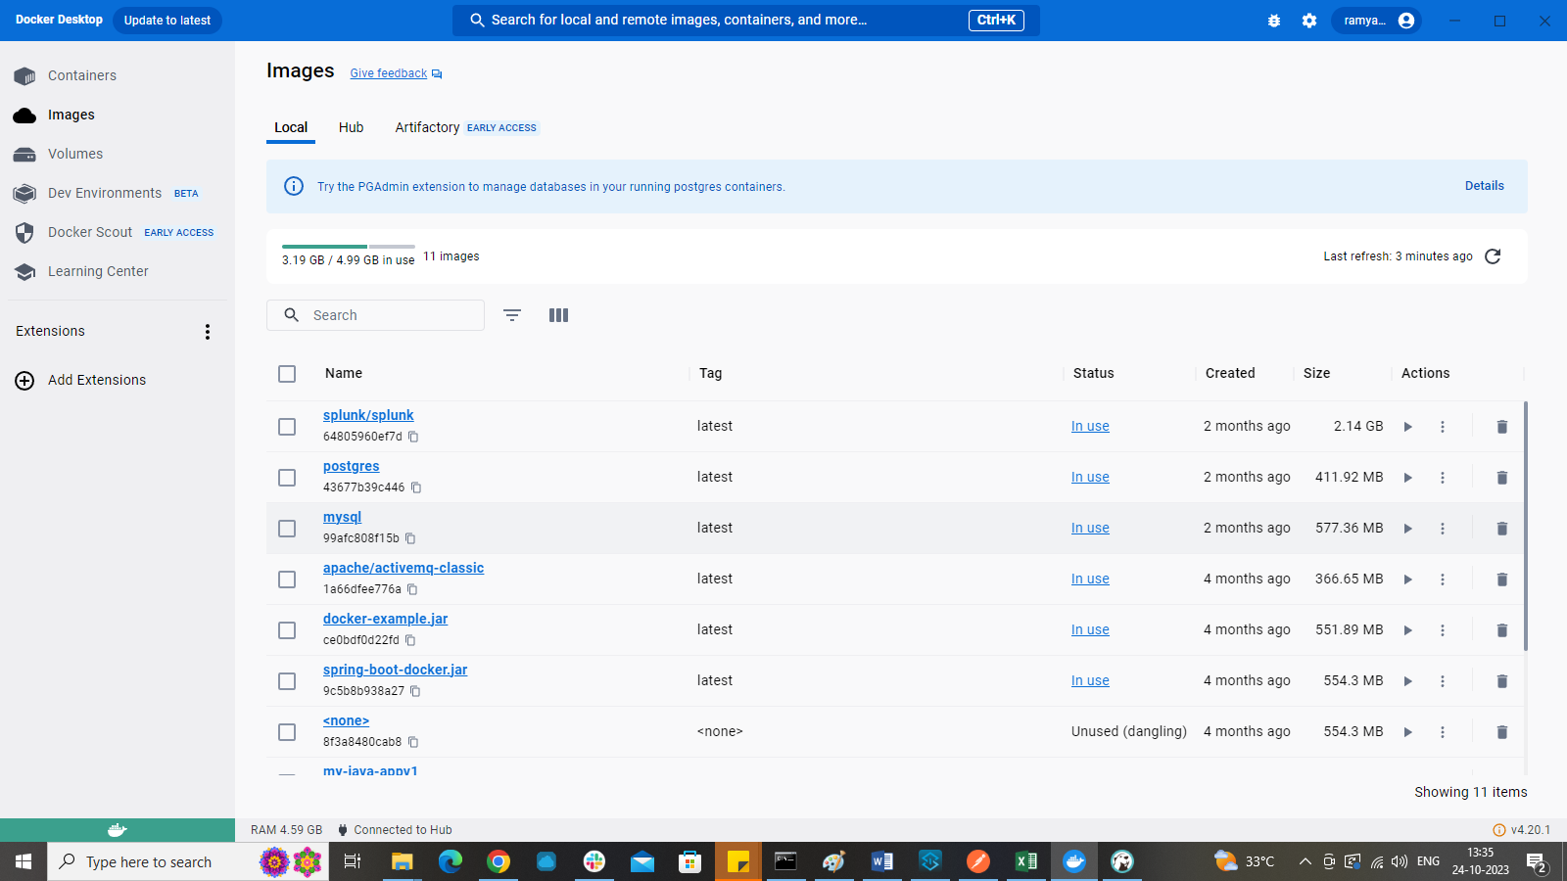

Container Creation:

Start the container by running the command or already instantiated container we can just click on Run option in containers tab.

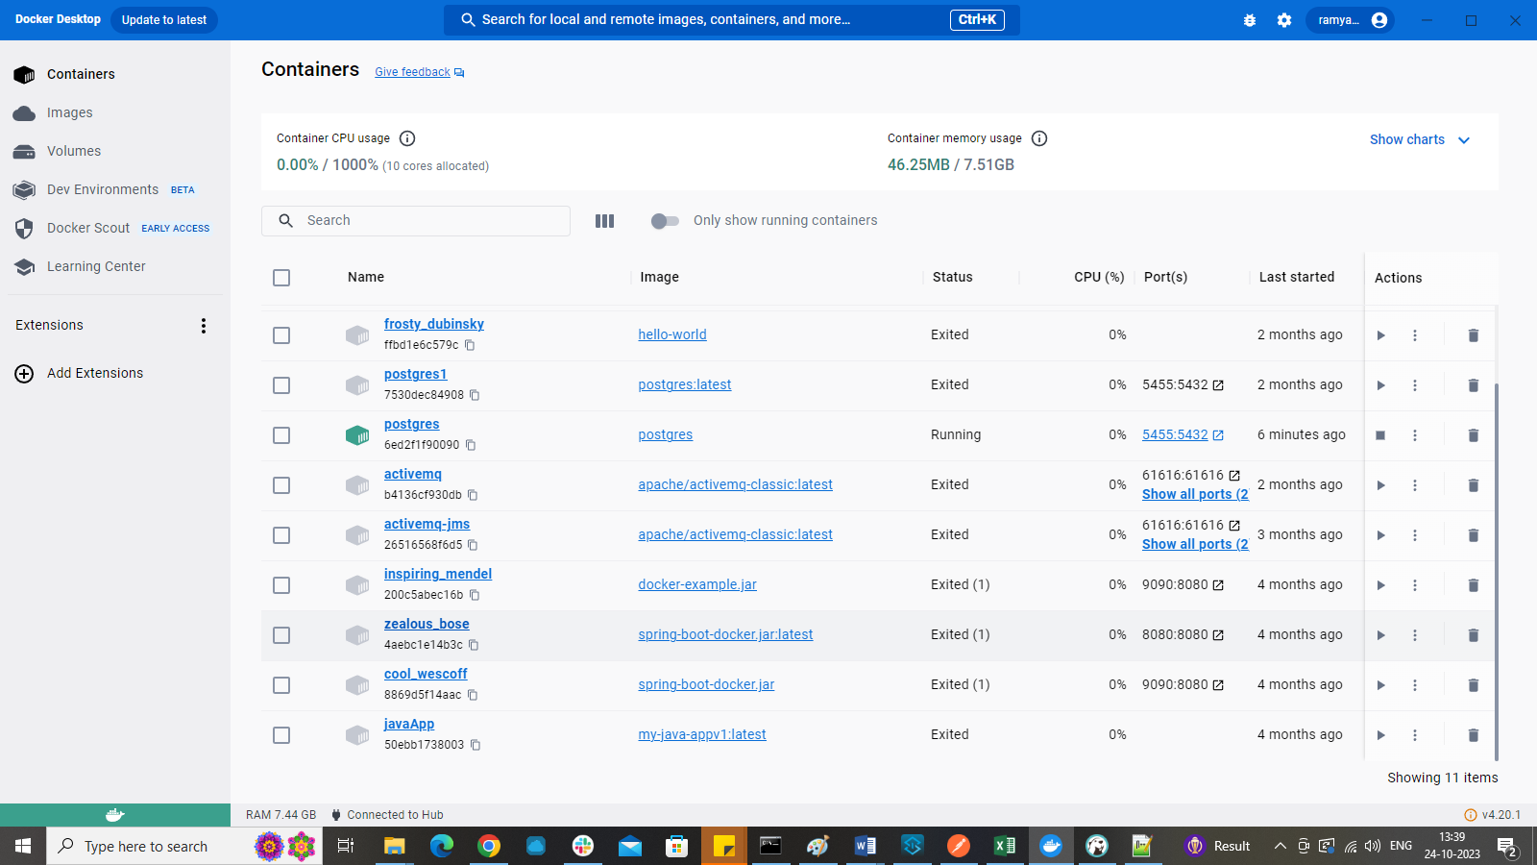

Postgres DB connection in Dbeaver:

Open Dbeaver app in the local system and provide the required credentials to connect to postgres database.

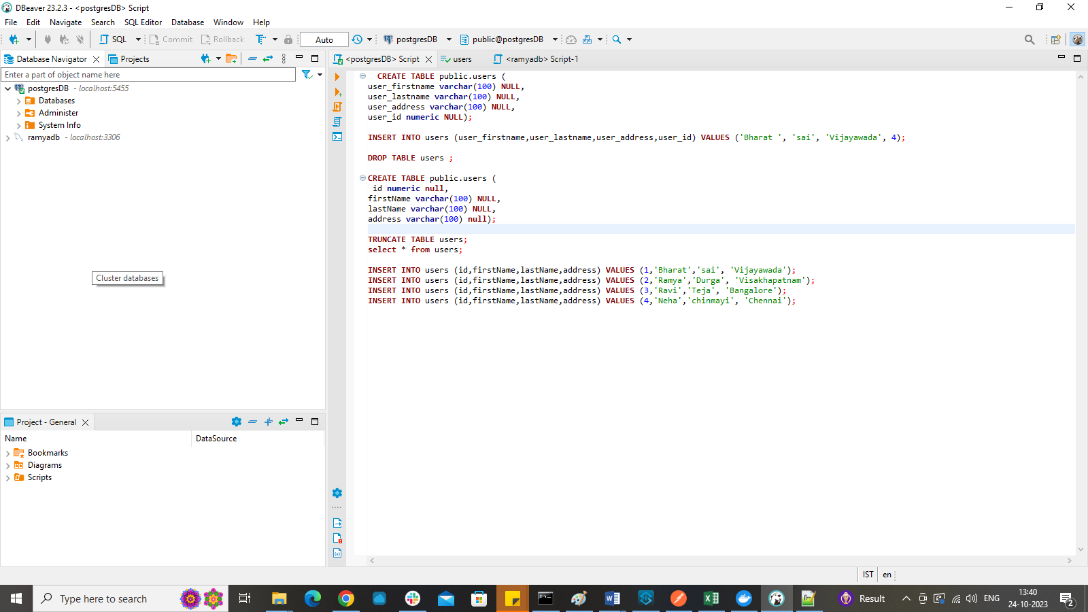

**Table creation:**

**QUERY:**

**CREATE** **TABLE** public.businesses (

Id numeric **NOT NULL**,  
Organization_Name **varchar**(100) **NULL**,  
Address **varchar**(100) **NULL**,  
City **varchar**(100) **NULL**,  
State **varchar(100)** **NULL**,  
Country **varchar**(100) **NULL**,  
Zip **varchar**(100) **NULL**,  
PhoneNumber **varchar**(100) **NULL**,  
Revenue **numeric** **NULL**,  
Created_Date **numeric NOT**  **NULL**,  
Notes **varchar**(1000) **NULL**,);

Using Dbeaver, we can see that the Table is created after running the query.

We can use import data option in the Dbeaver to import 1000 records from the csv example file.

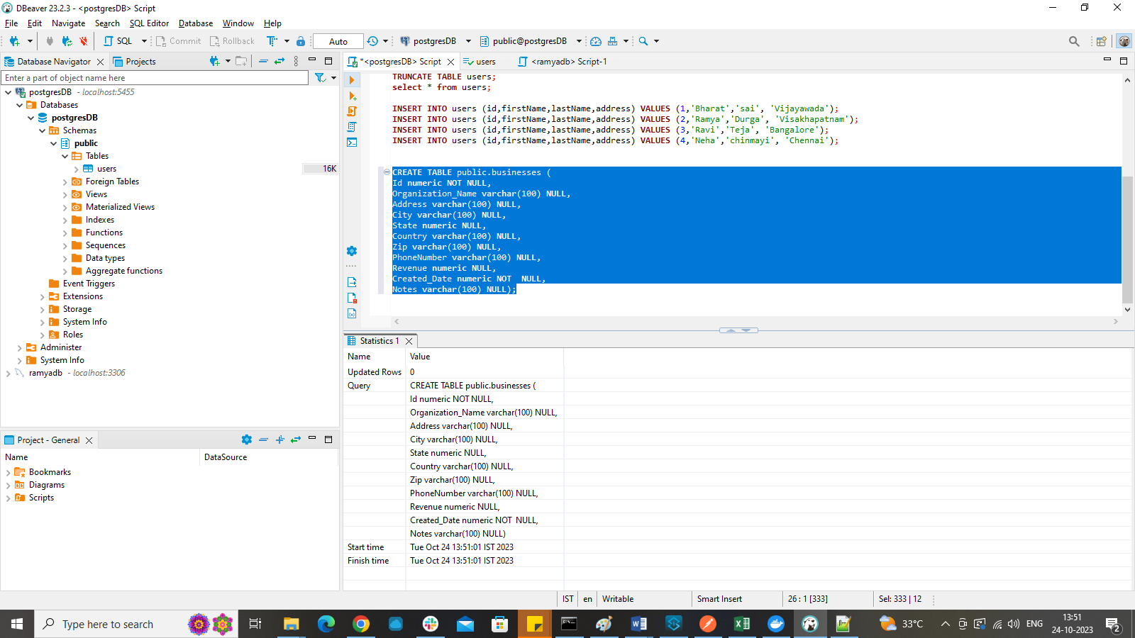

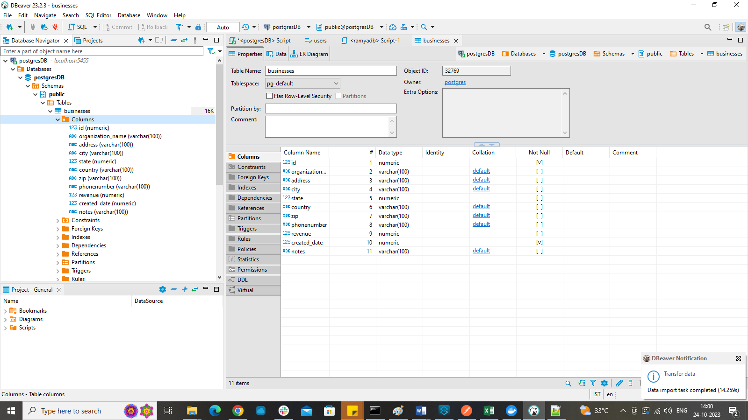

INSERTING DATA INTO TABLE:

If the import data option in D

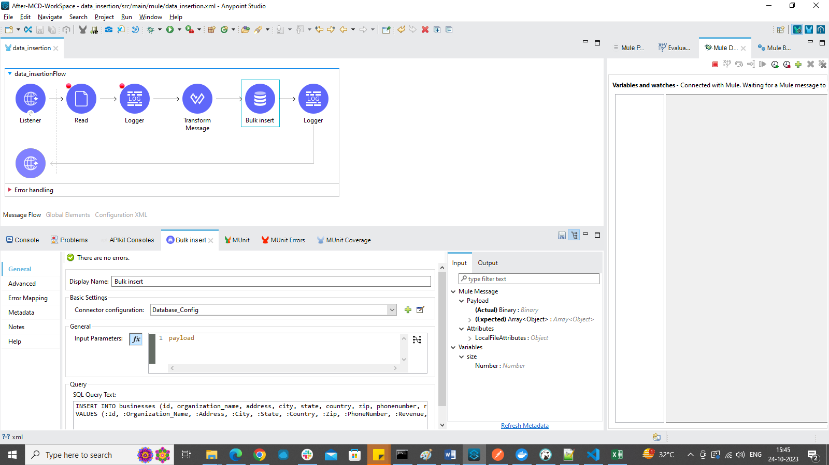

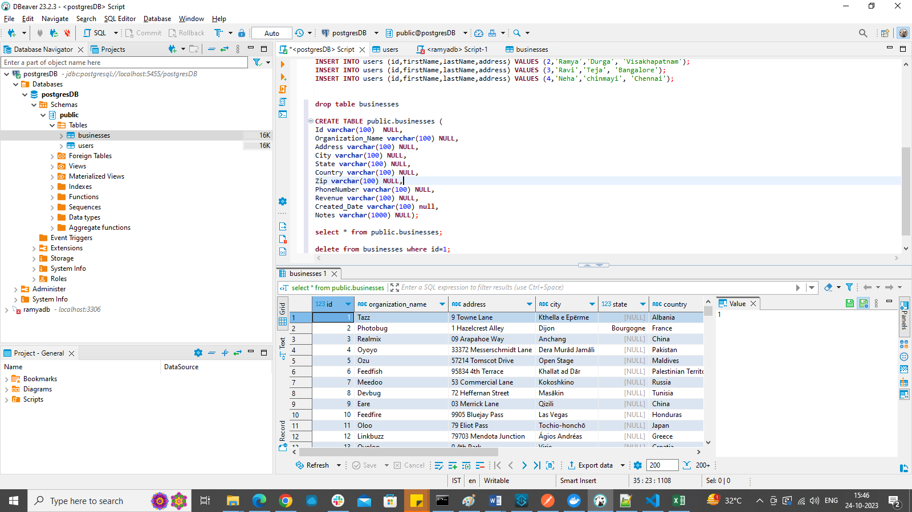

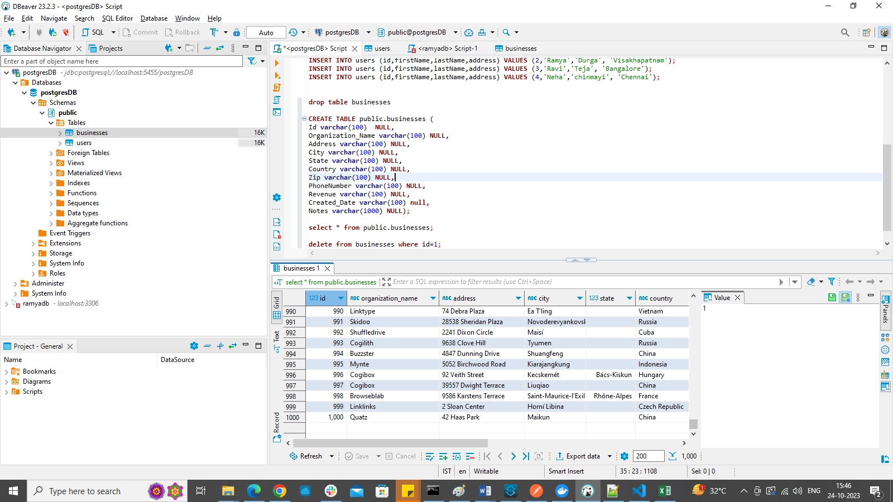

CREATING API SPECIFICATION:

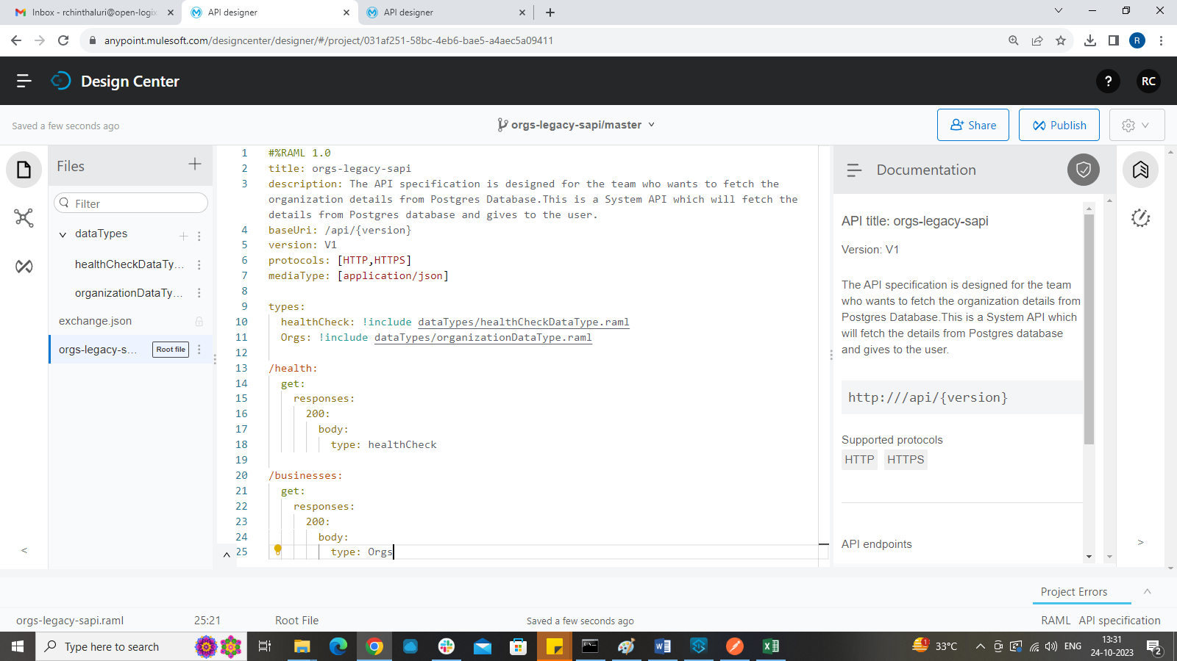

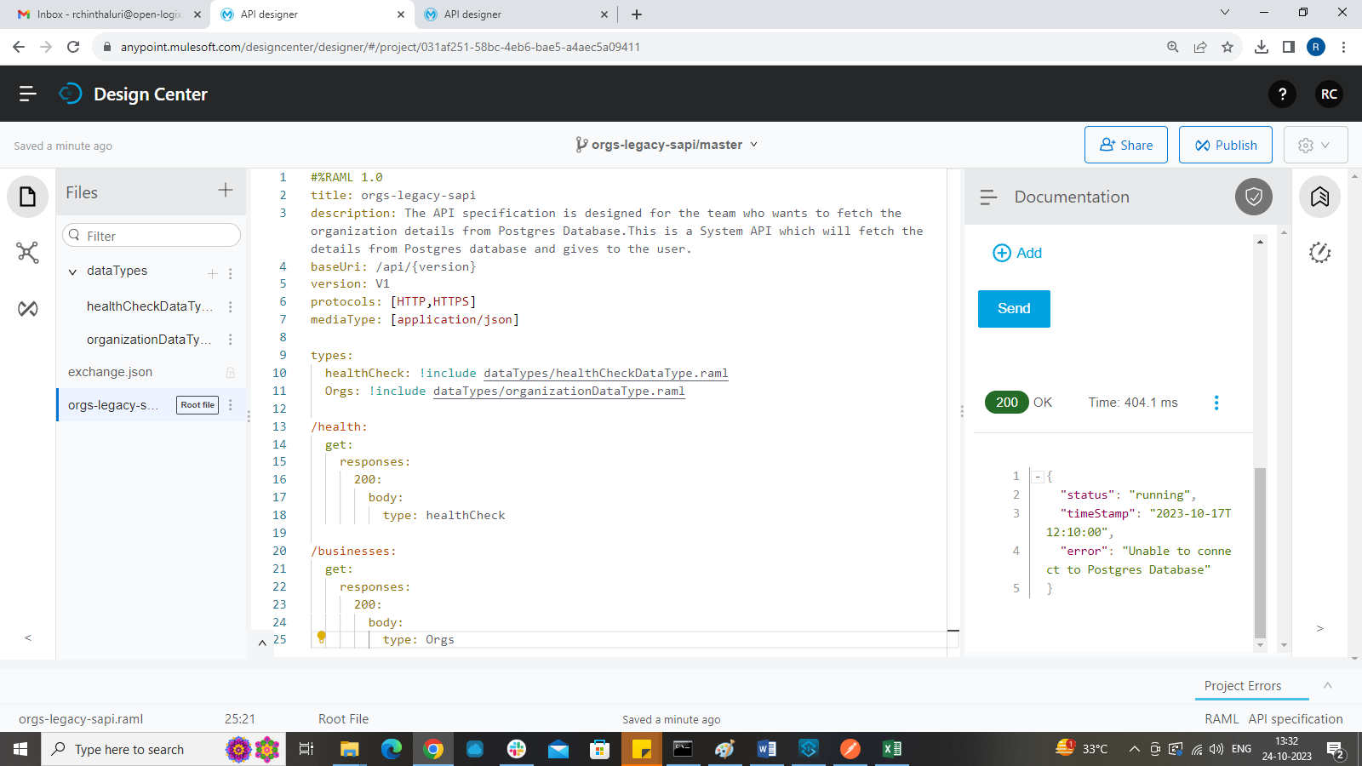

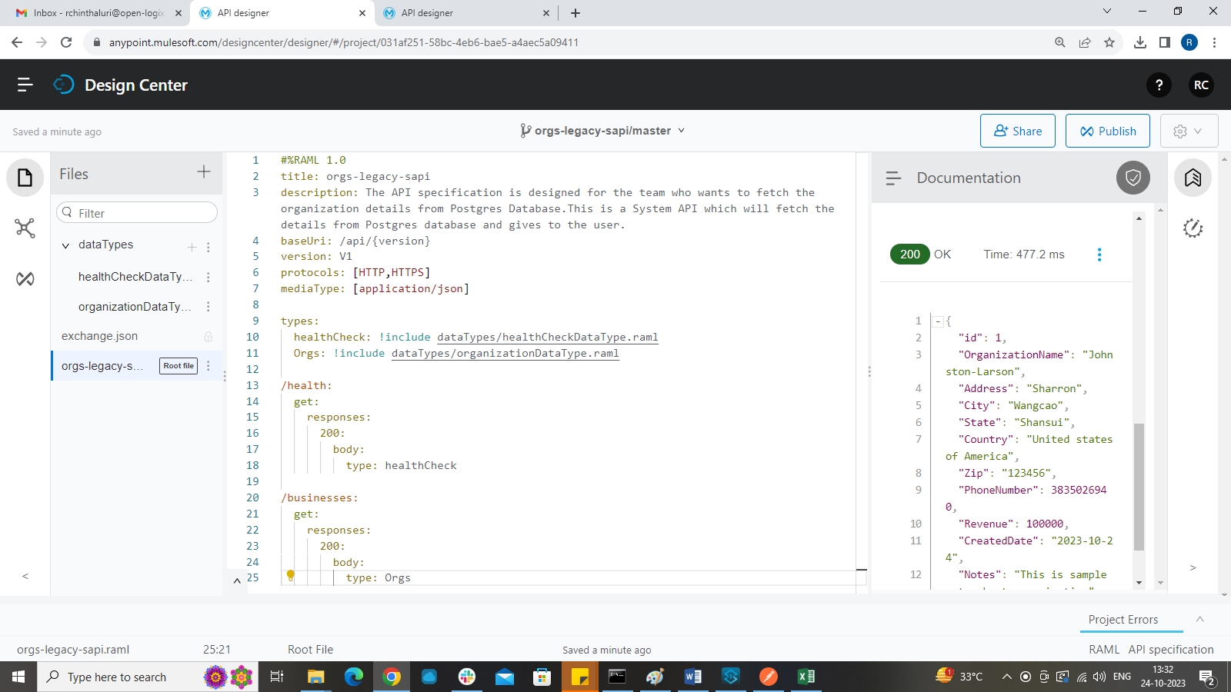

Publishing to exchange:

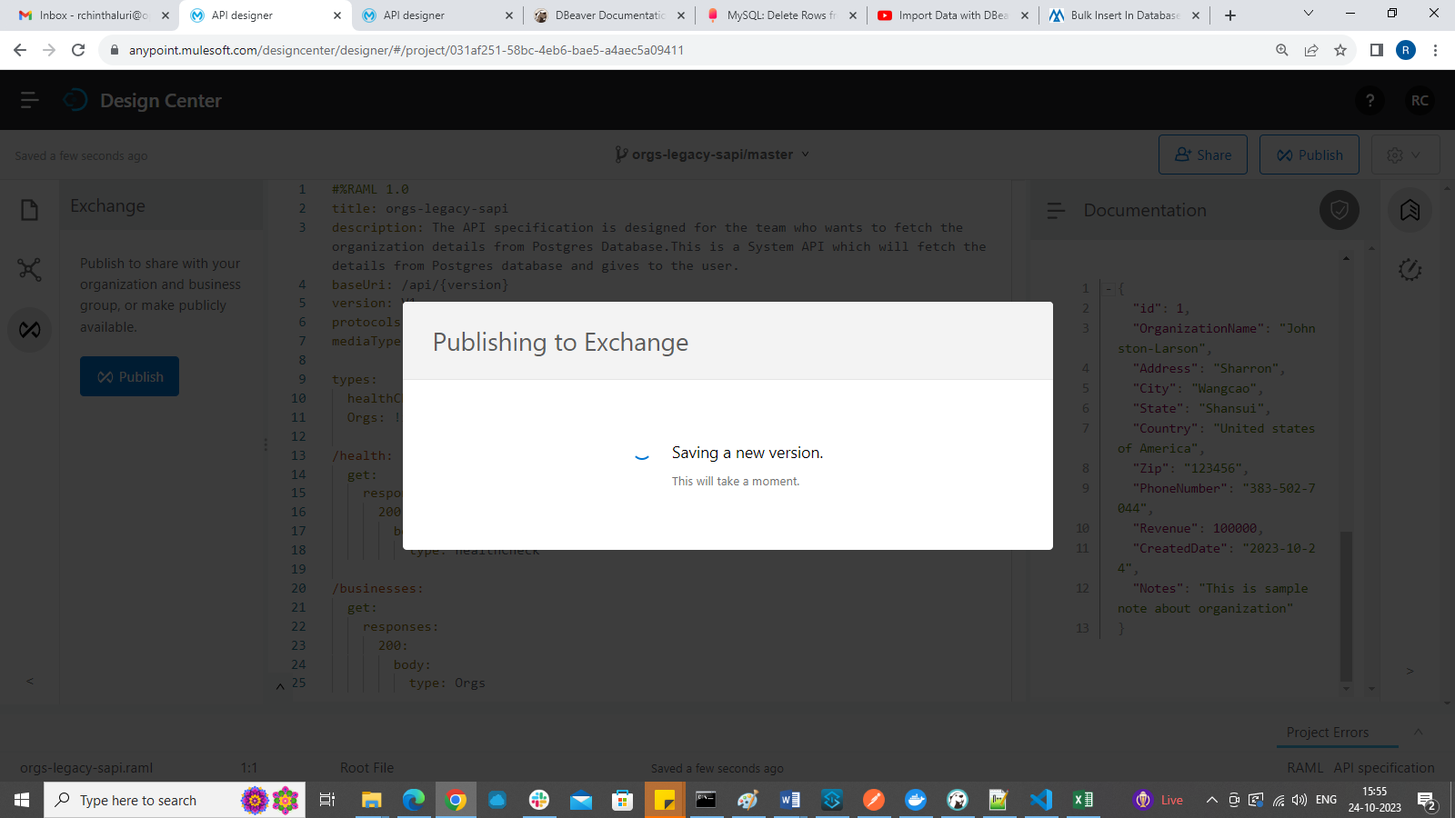

IMPLEMENTATION:

Scaffolding:

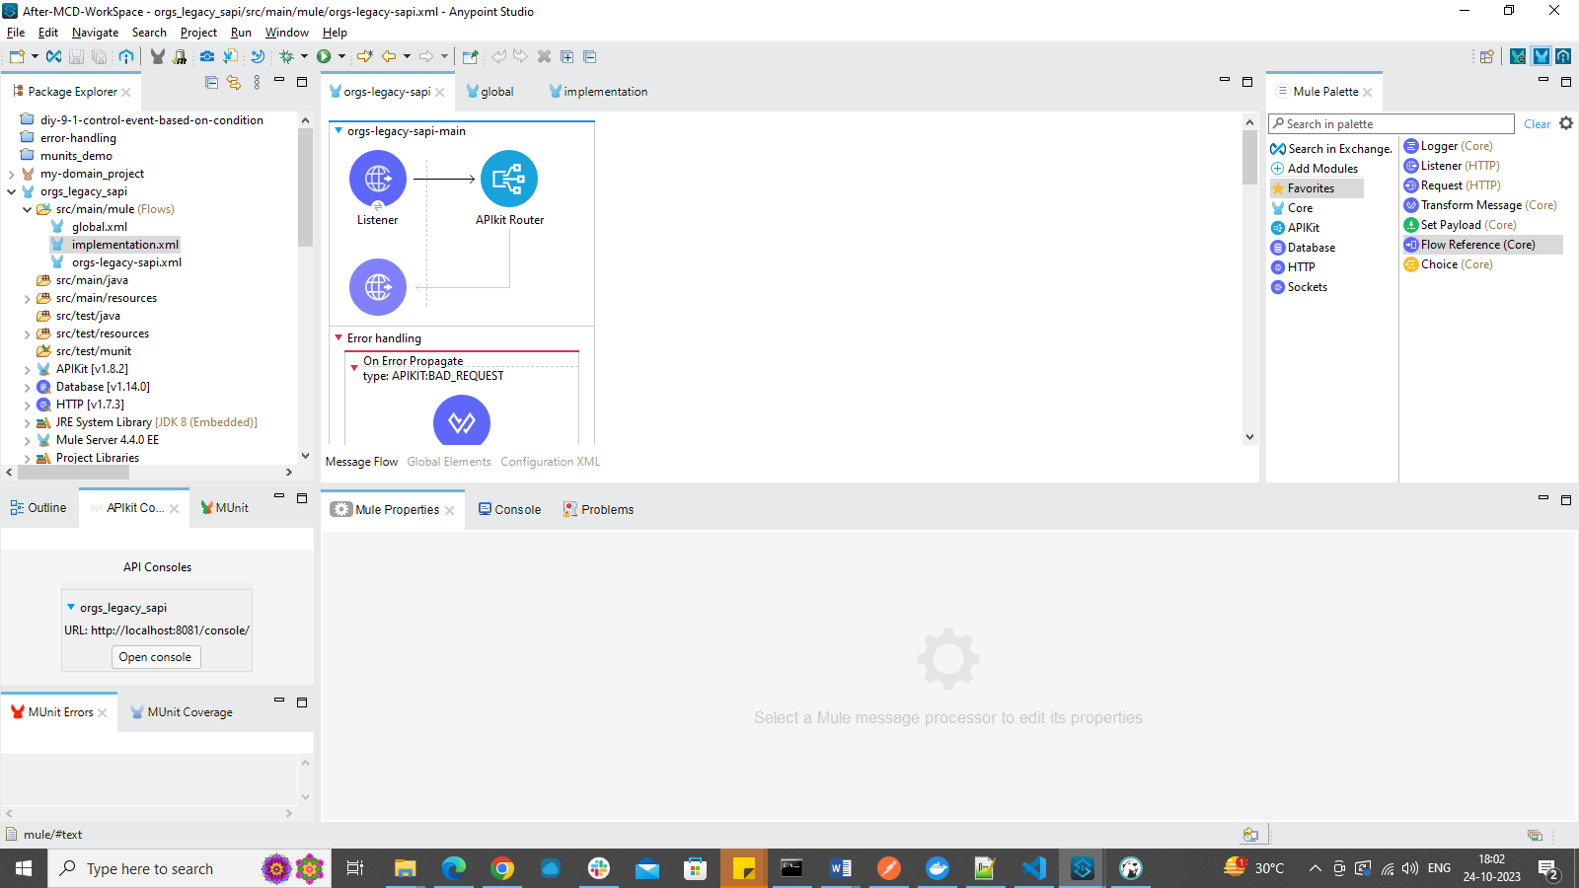

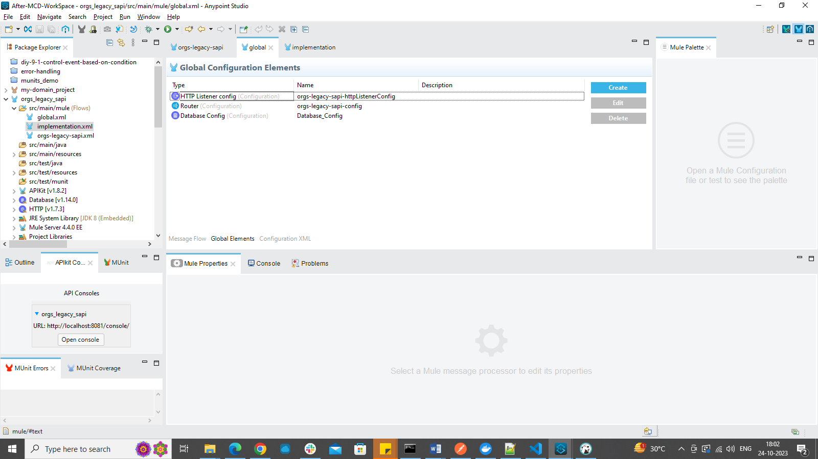

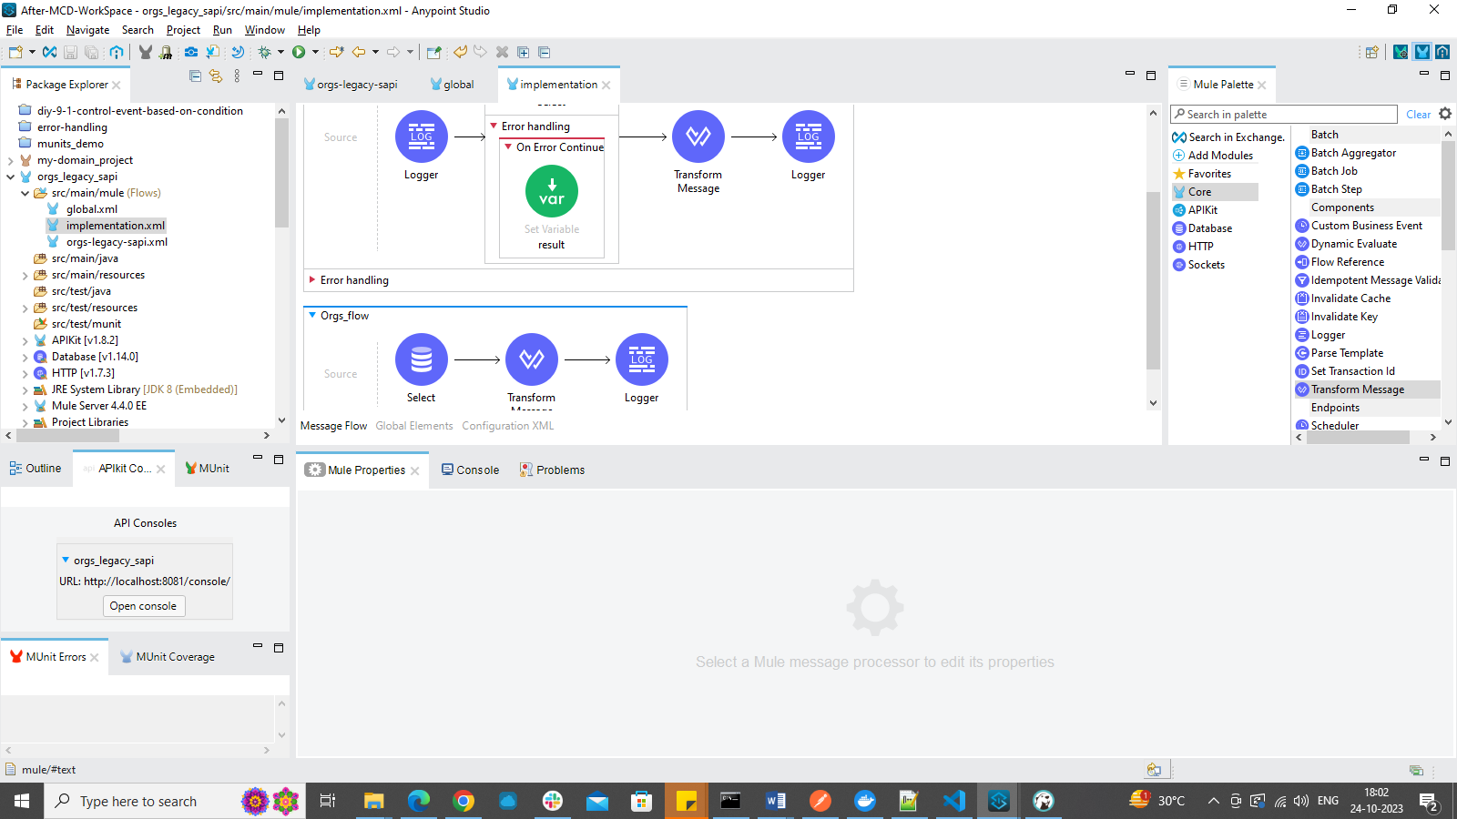

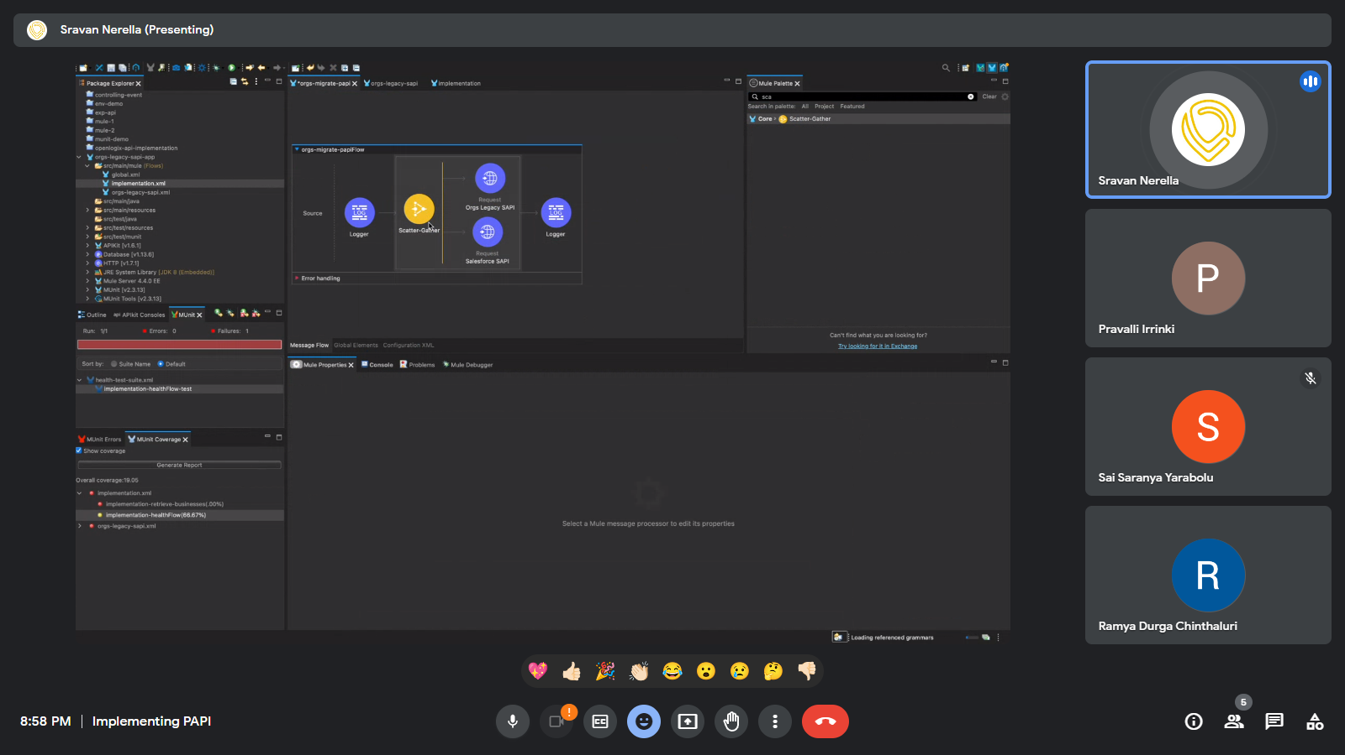

HYBRID DEPLOYMENT:

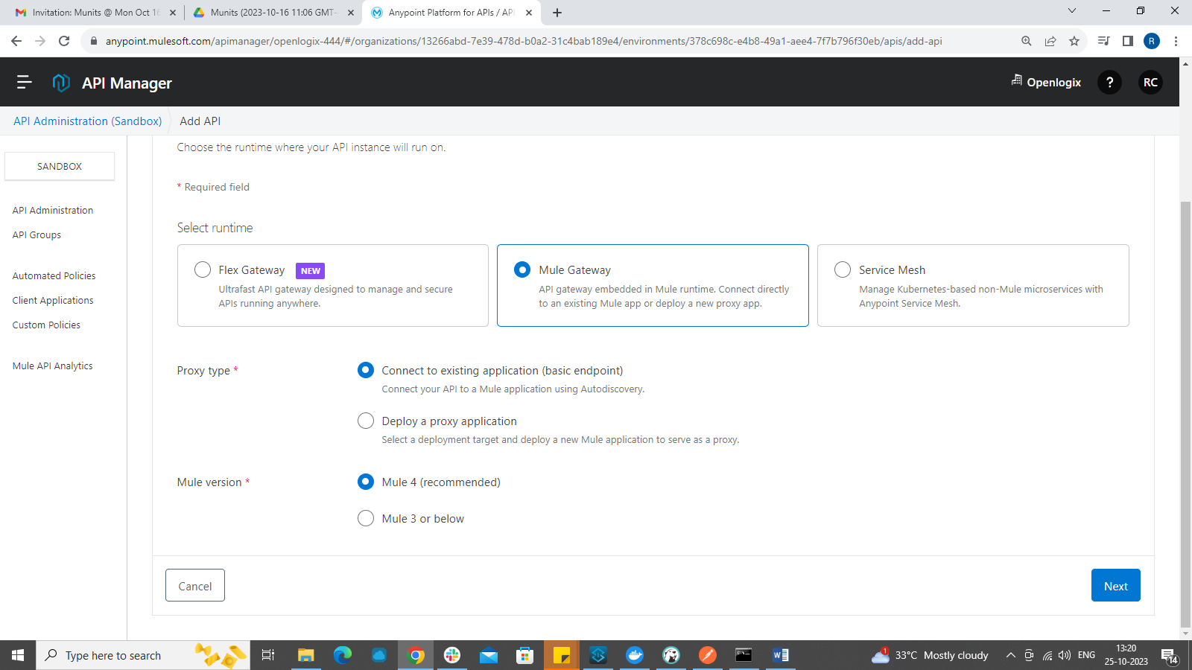

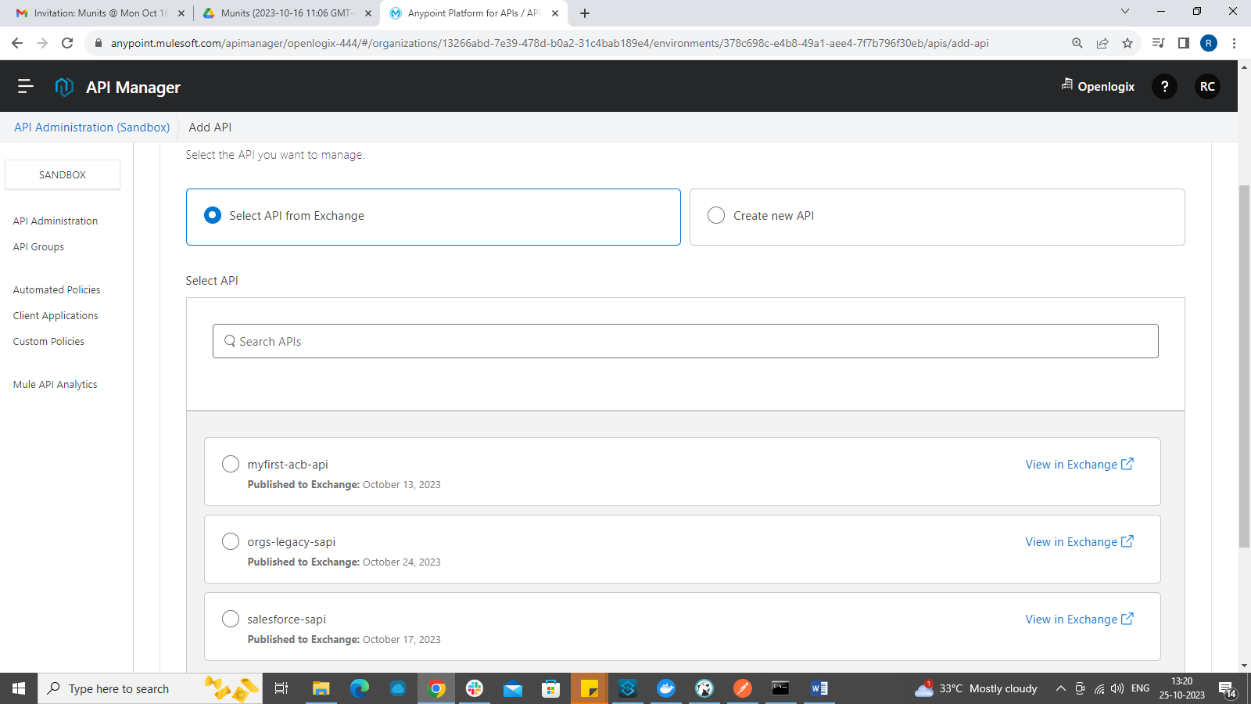

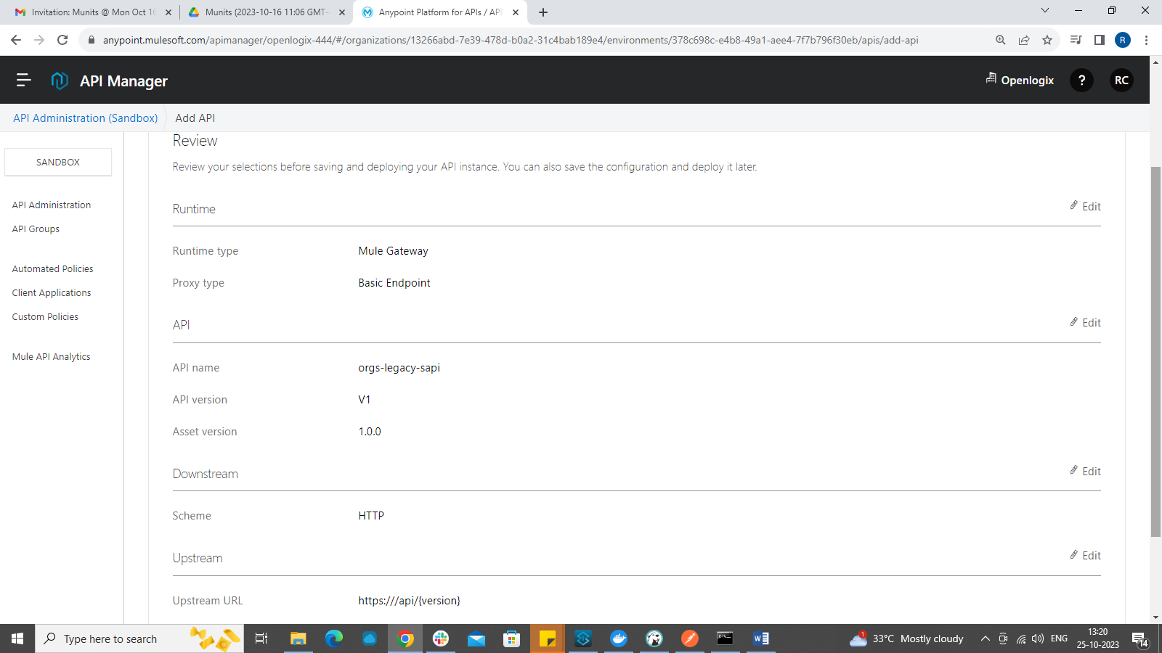

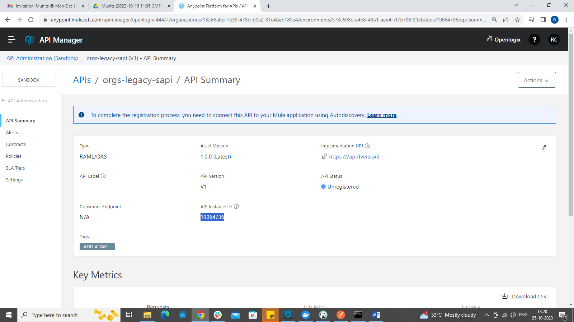

API auto discovery:

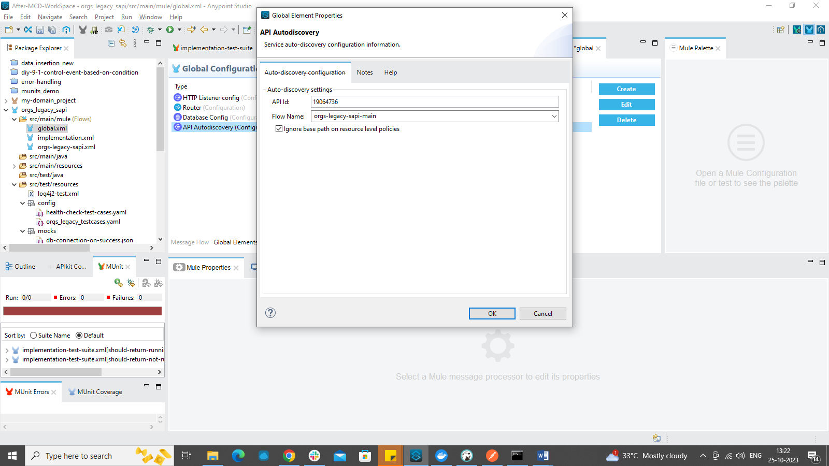

Output After auto discovery: 503 error

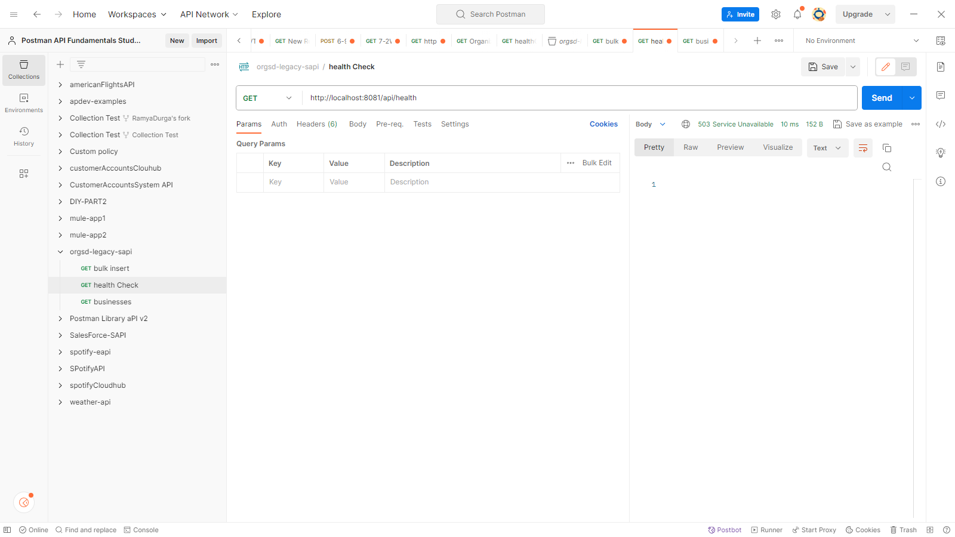

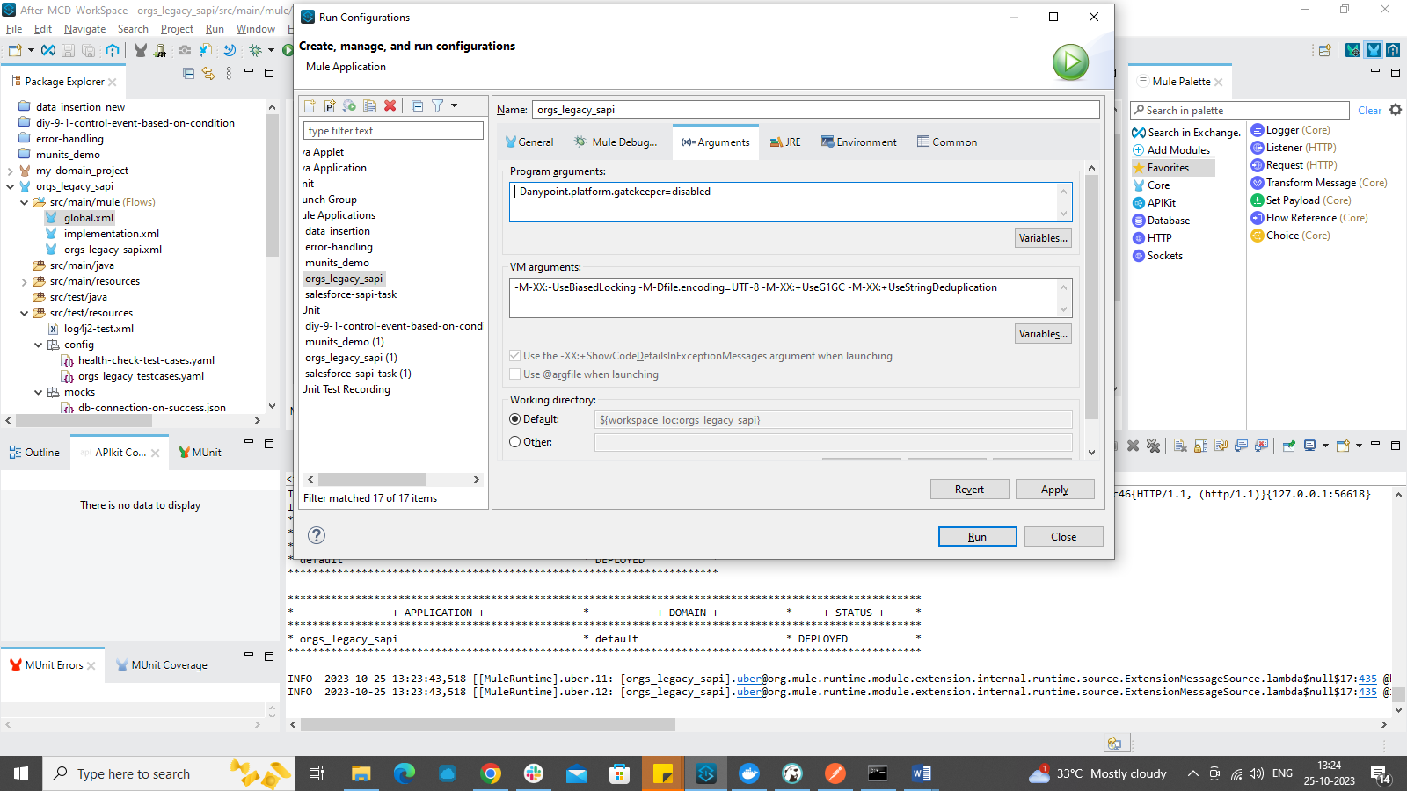

After disabling gate keeper:

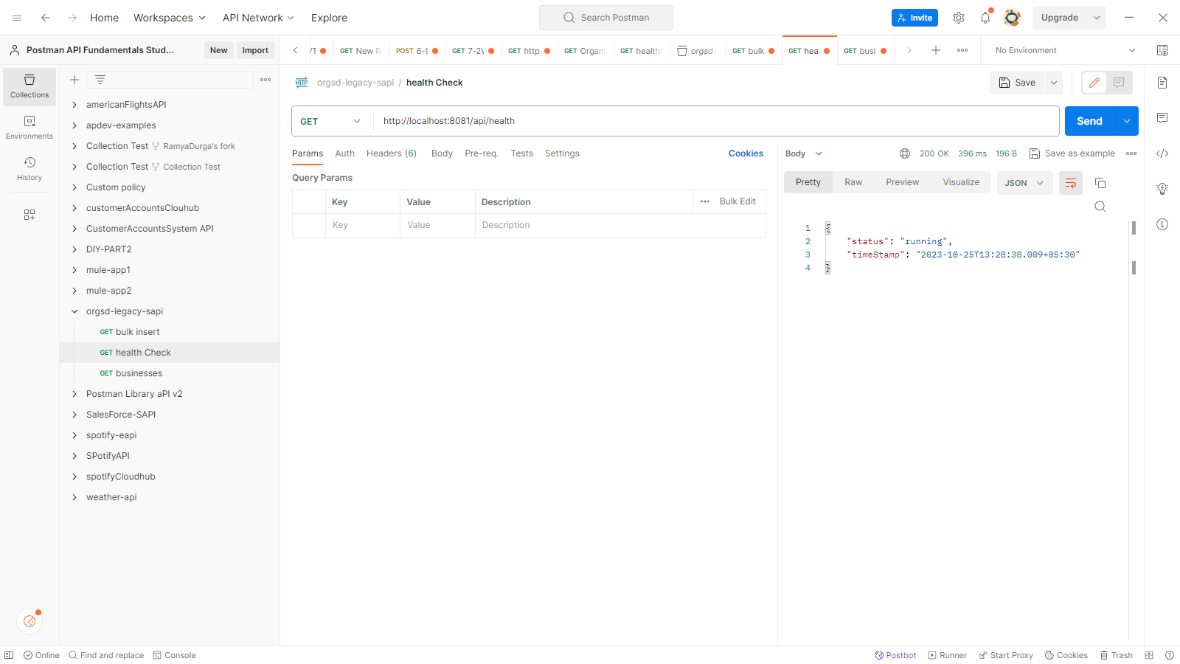

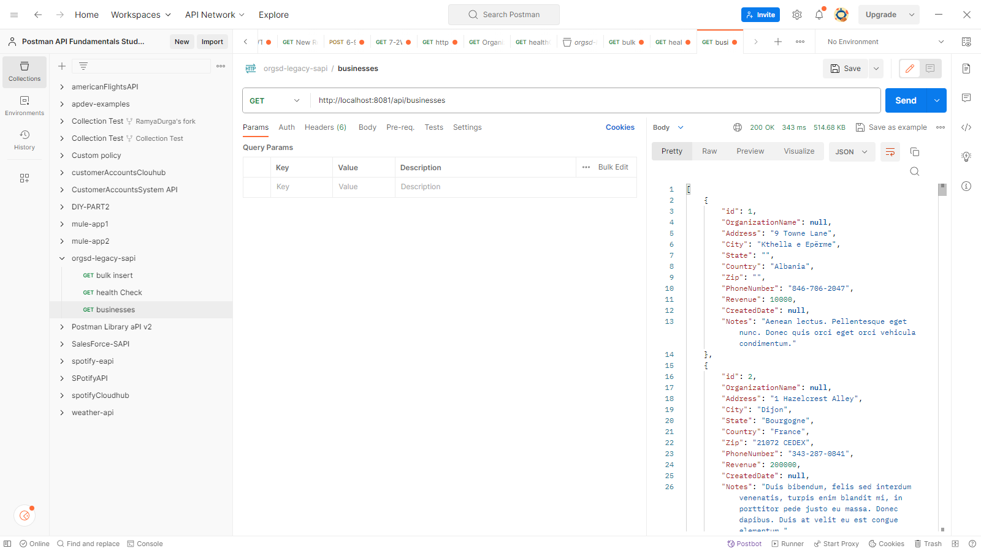

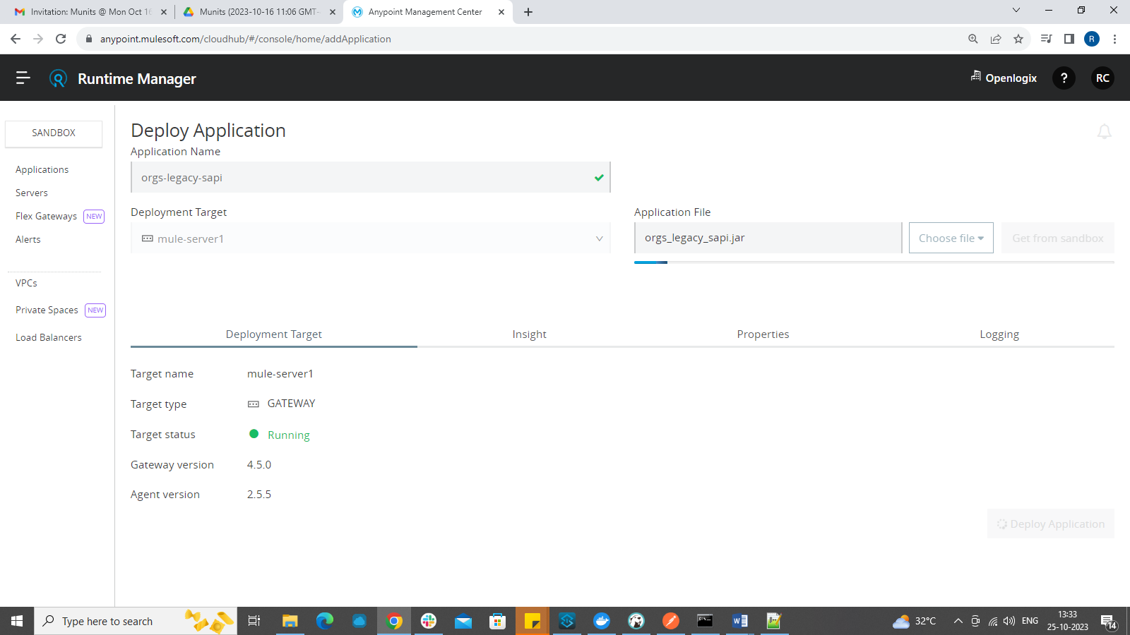

Out of memory-metaspace Error:

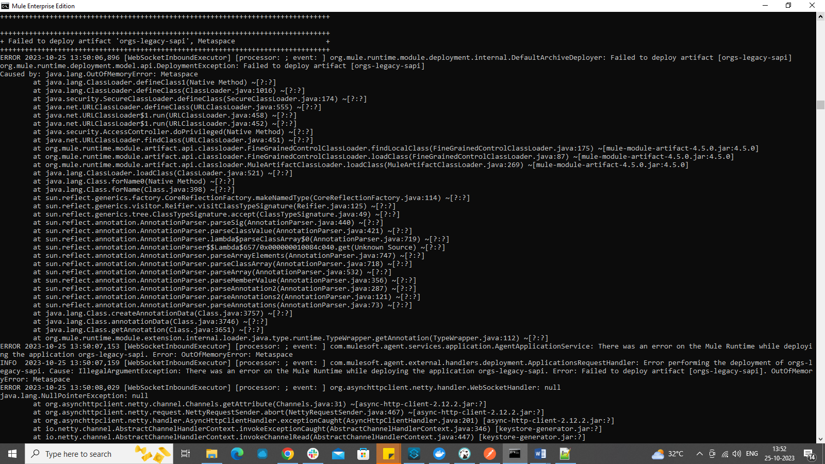

Increased metaspace in wrapper.conf file:

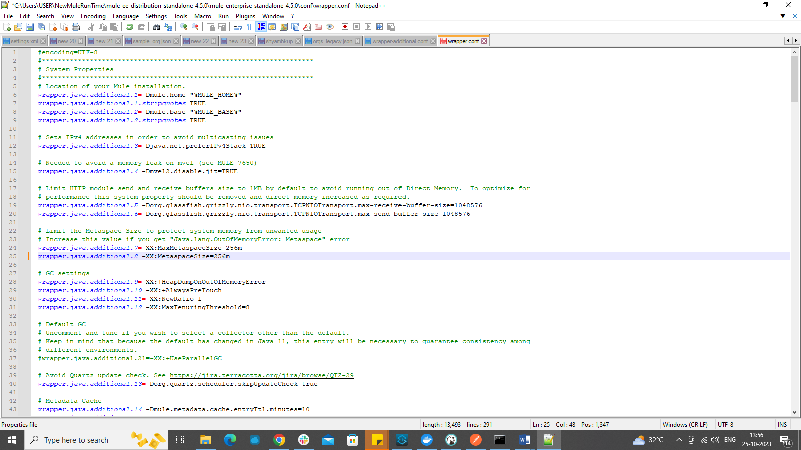

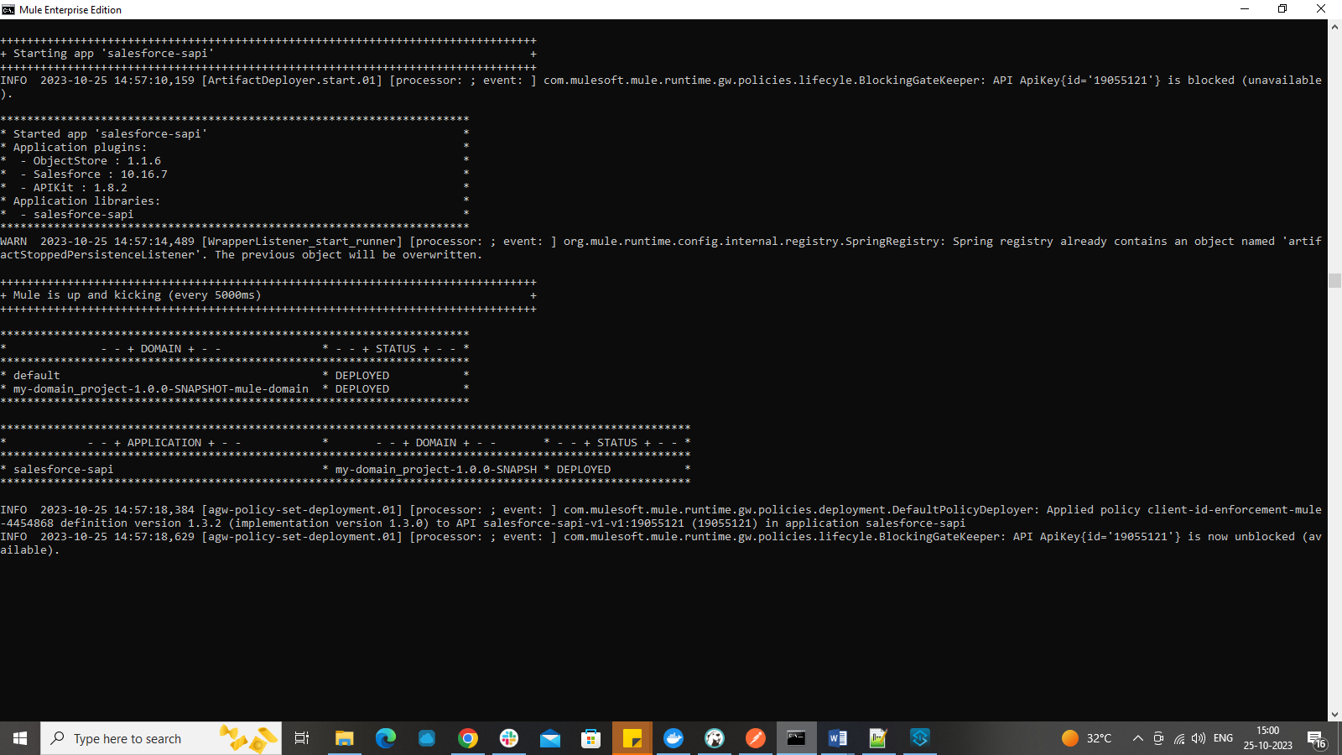

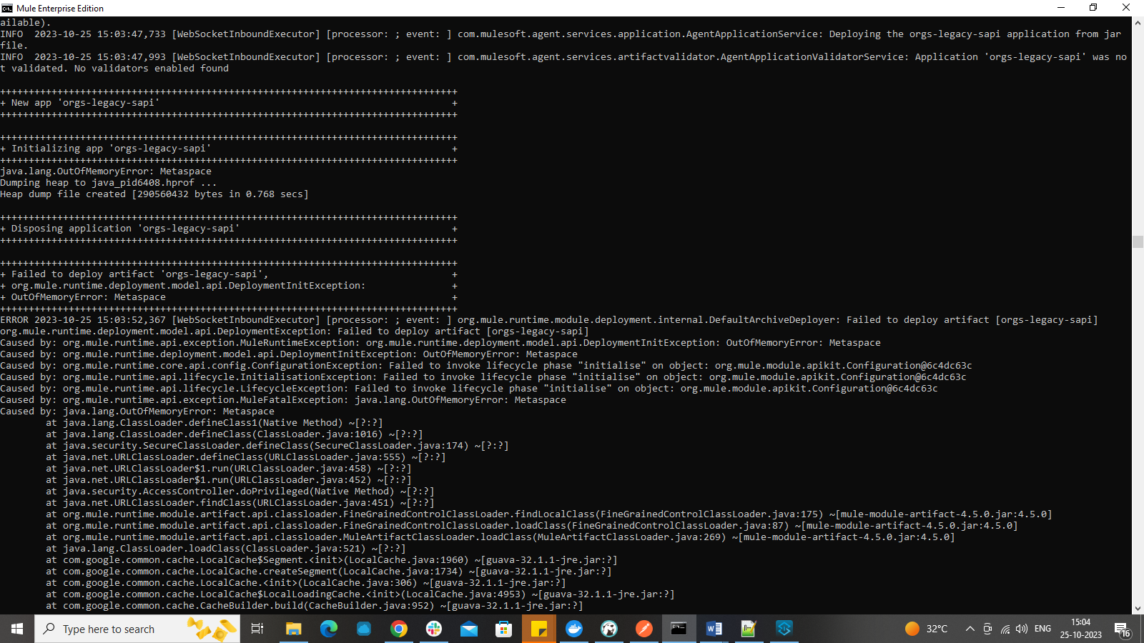

After clearing the out of memory issue:

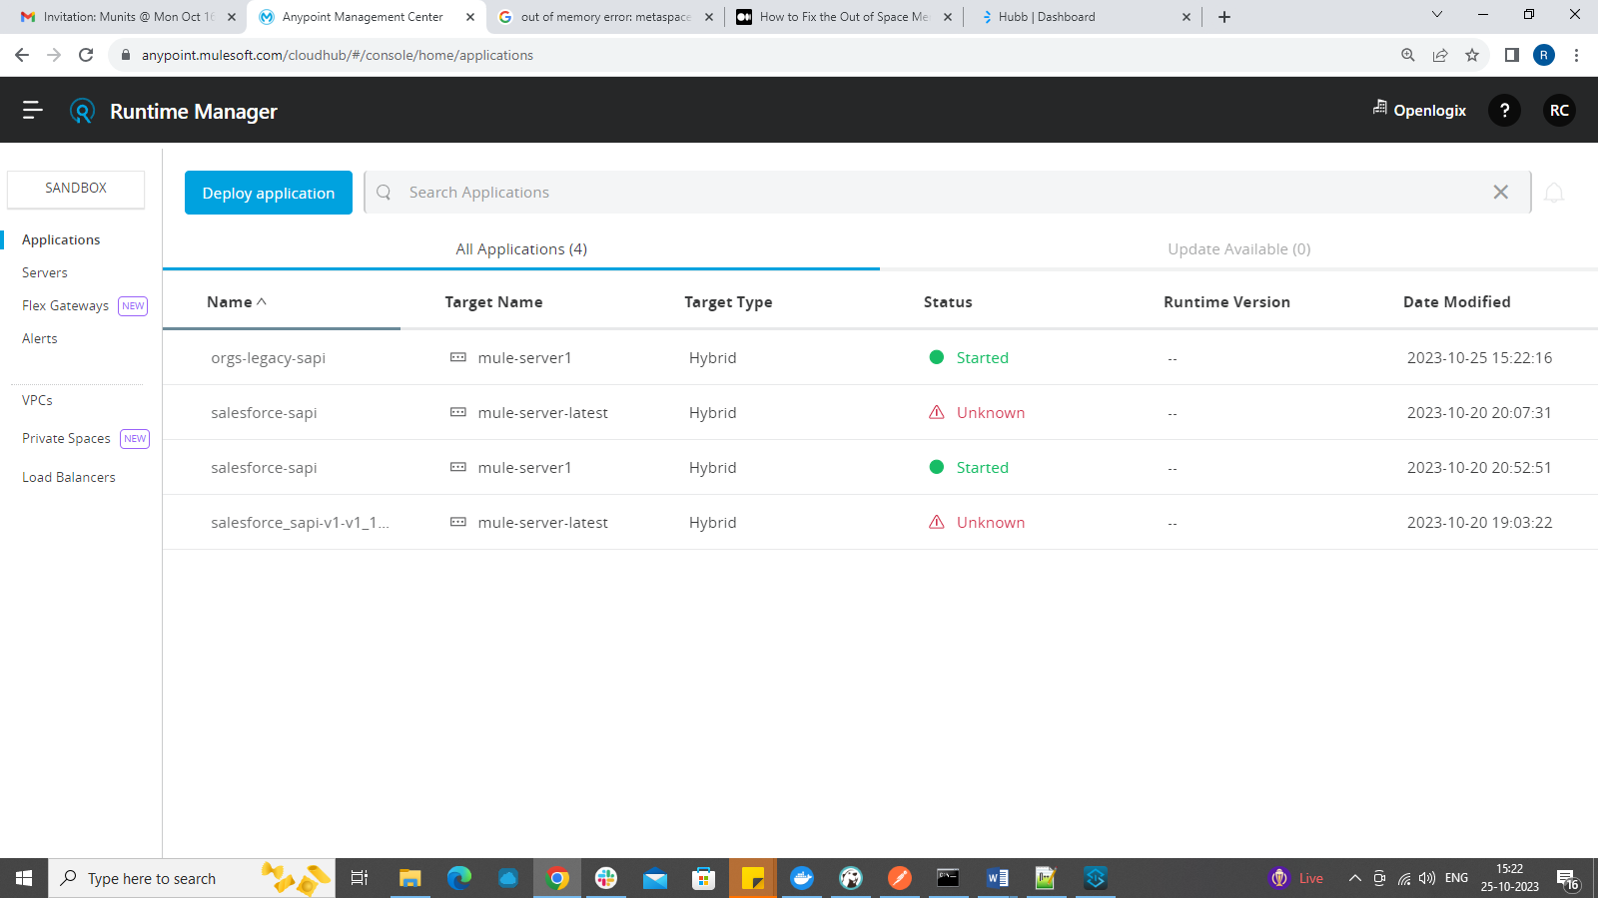

**MIGRATION PAPI**

API spec:

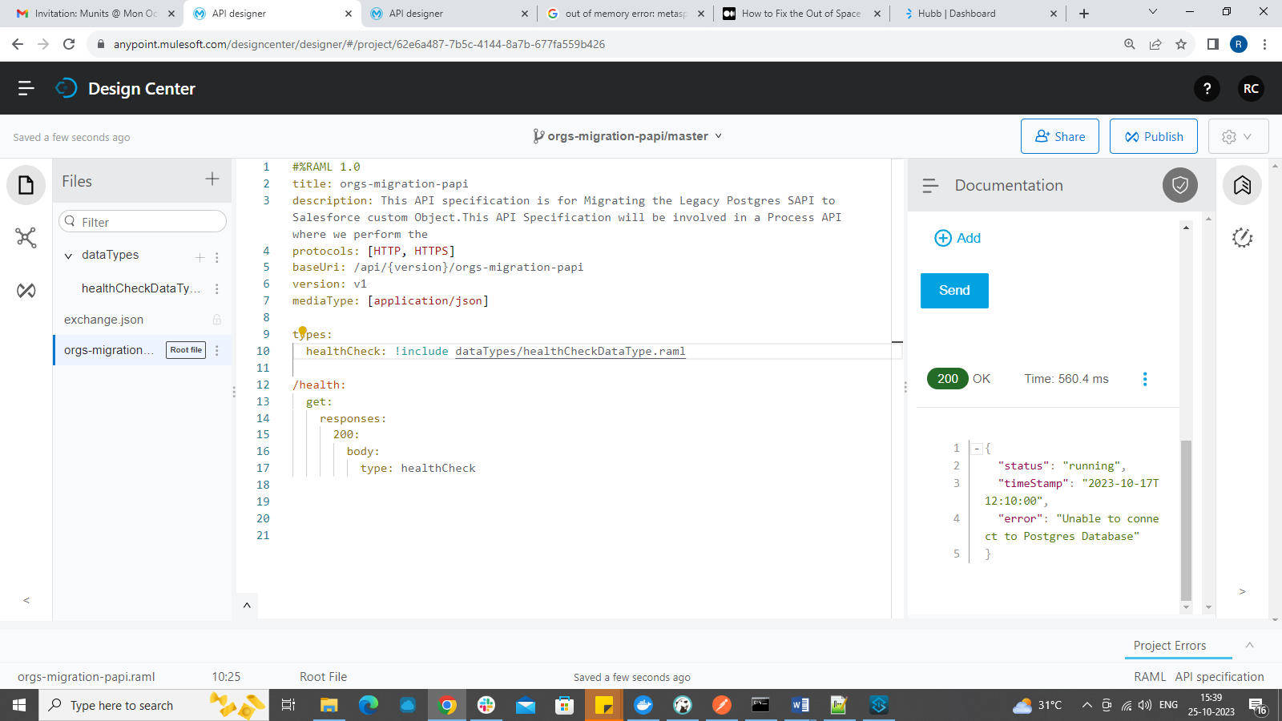

Implementation:

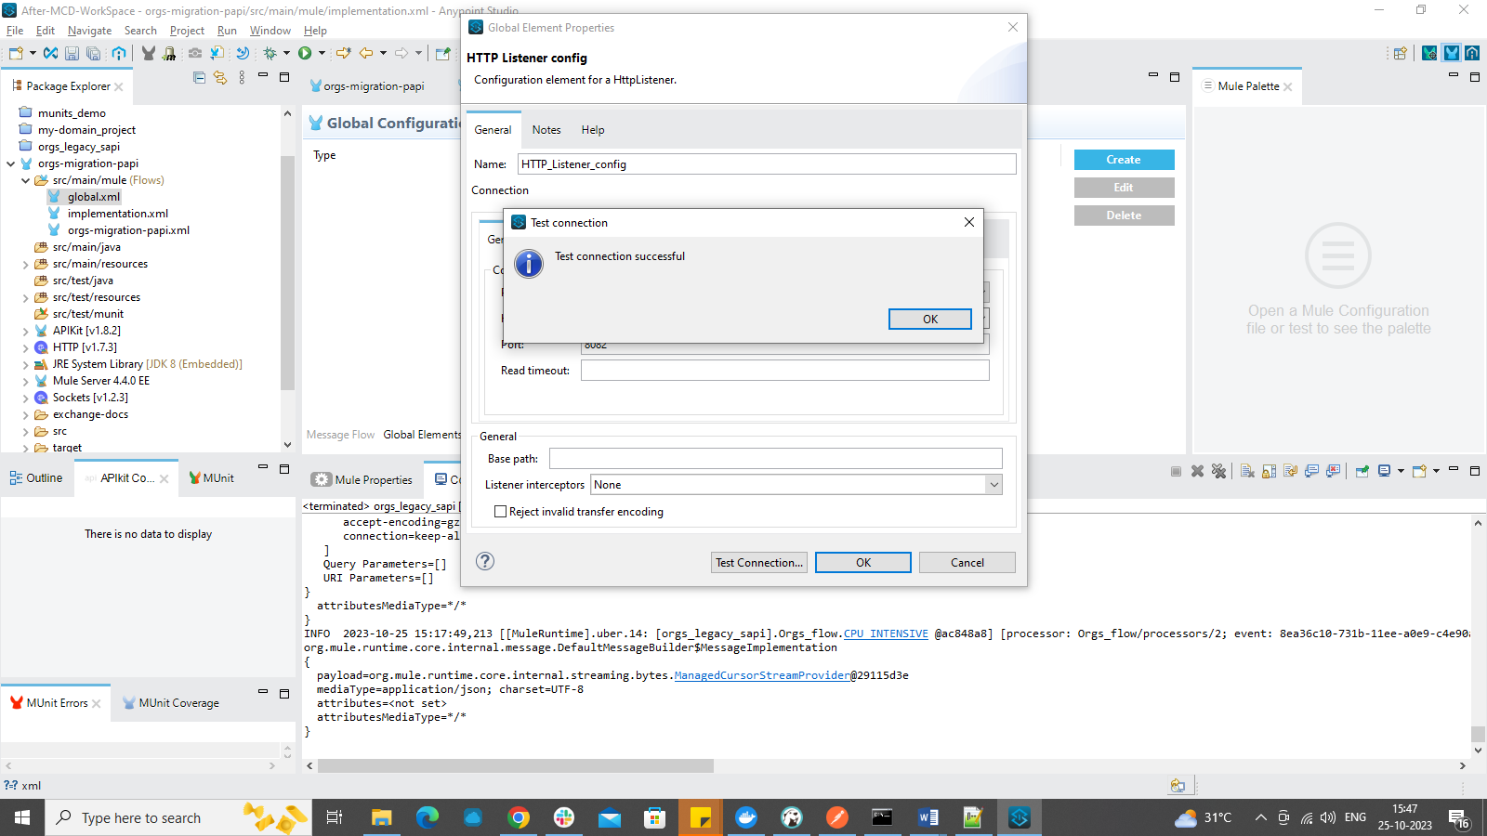

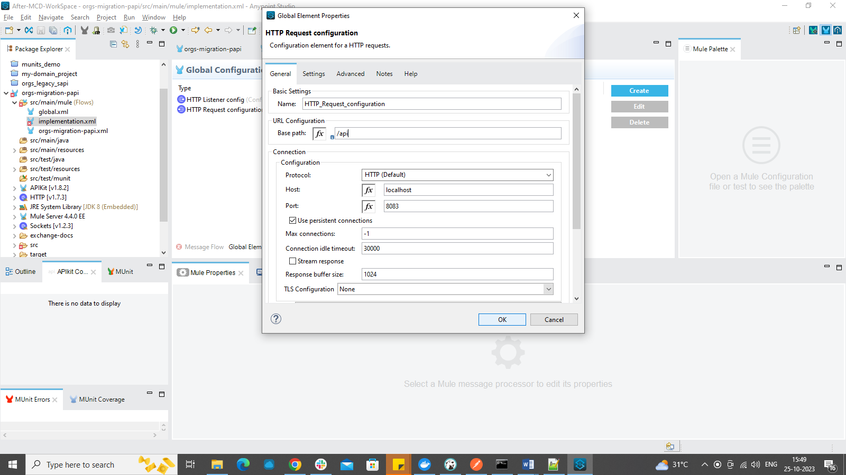

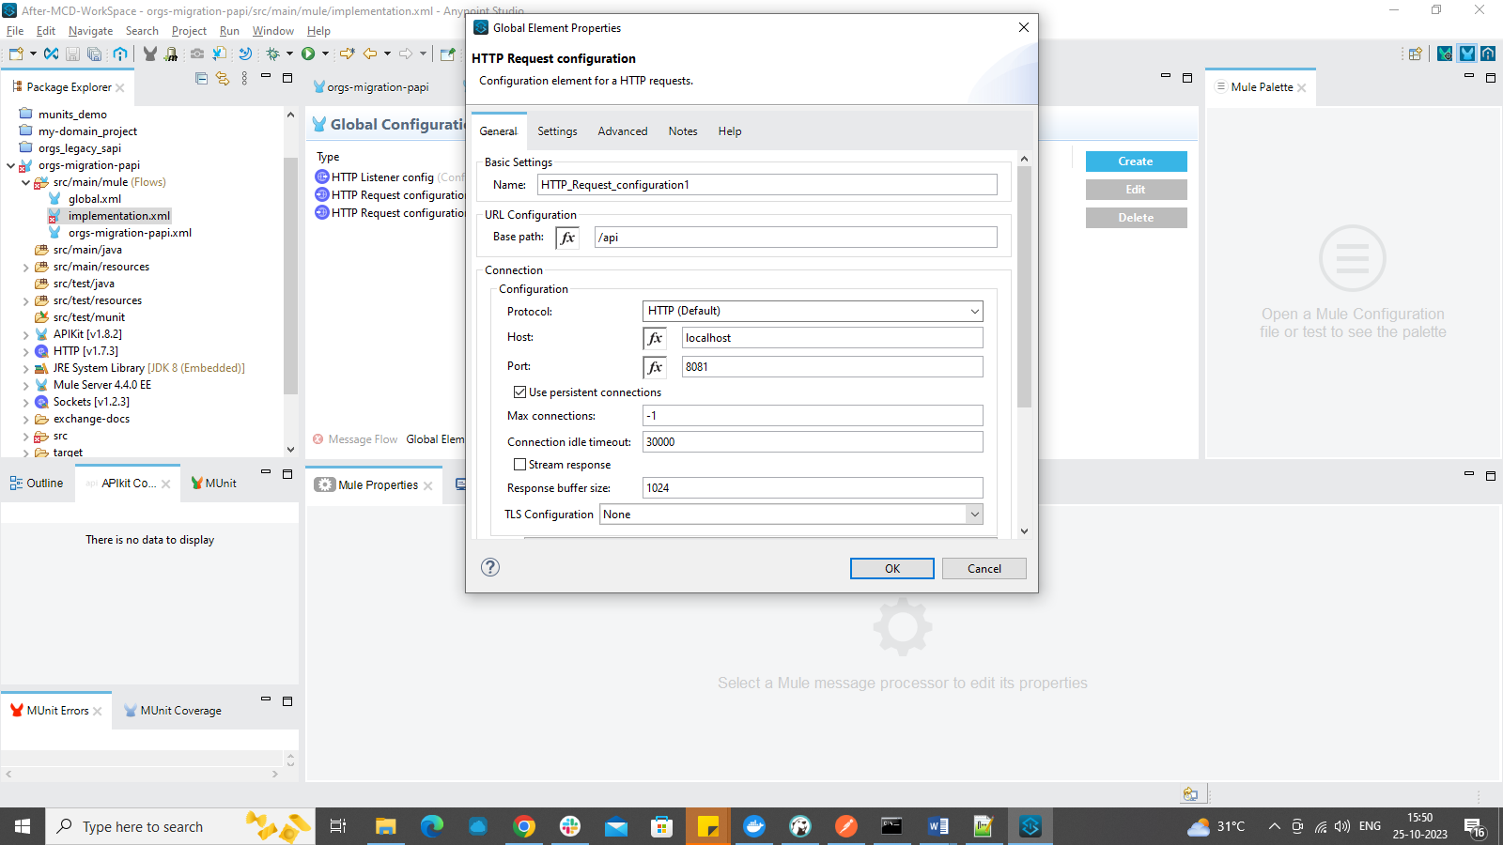

Splunk:

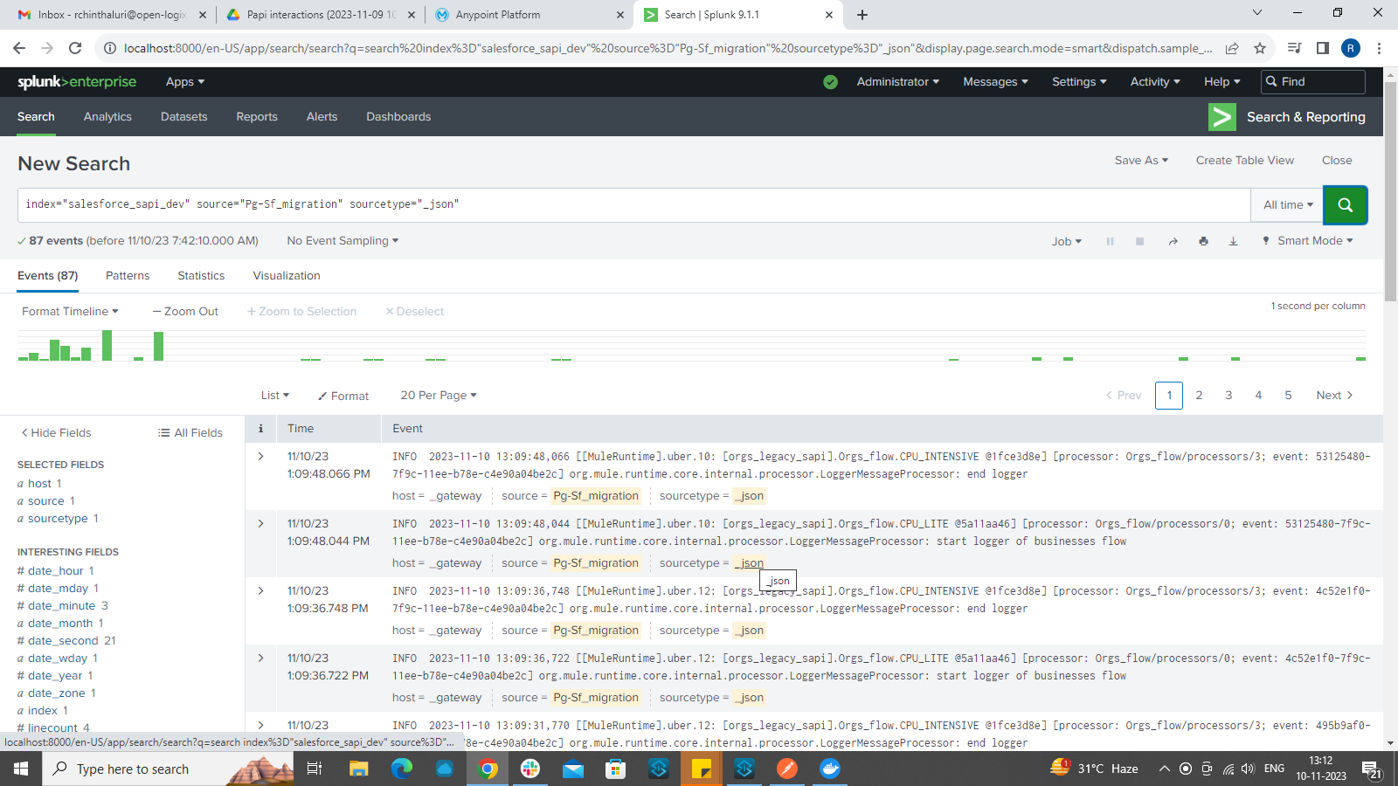

Both apps logs:

index="salesforce_sapi_dev" source="Pg-Sf_migration" sourcetype="_json"

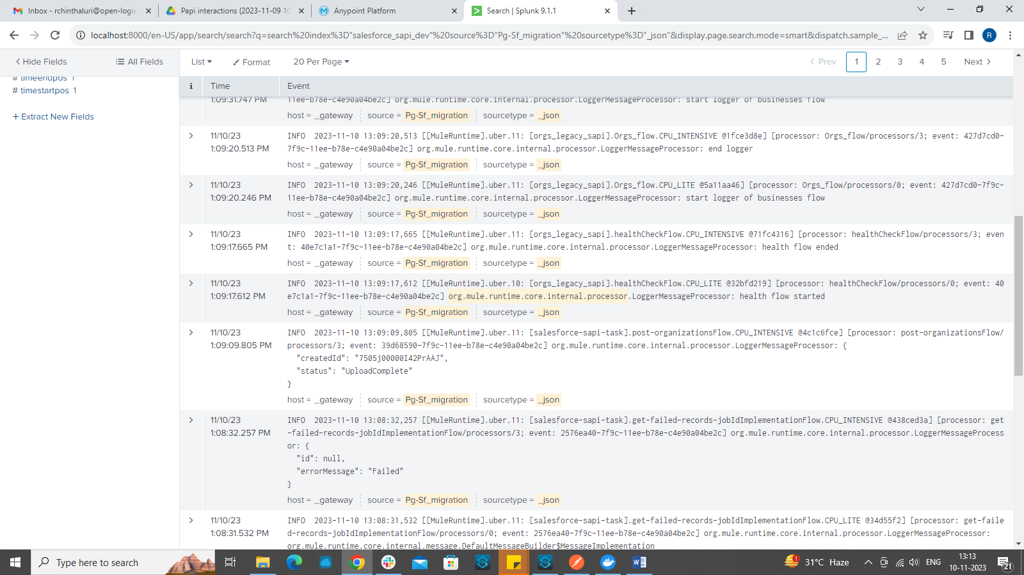

Correlation id sent through postman header reflecting in splunk

